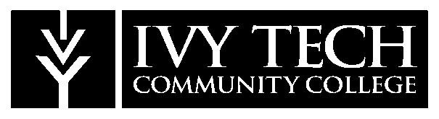 NEWS RELEASE

FOR IMMEDIATE RELEASE – March 6, 2024
For further information, contact:
Megan Earls, Director of Marketing
mearls8@ivytech.edu
Ivy Tech Madison Campus announces the launch of the Madison Vocational Partnership (MVP)
MADISON, Ind. – Ivy Tech Madison Campus is proud to announce the launch of the Madison Vocational Partnership (MVP), an initiative aimed at providing students with career opportunities in collaboration with local employers. Through this innovative partnership, Ivy Tech Madison and Grote Industries, LG&E/KU, and Nucor Gallatin are joining forces to open dynamic career pathways for those students who are interested in earning their associate’s degree, while also exploring career opportunities in industry, information technology, or business.

The MVP program is designed to equip students with the skills and knowledge necessary to thrive in today's competitive job market and to put them on the fast track to a career. By leveraging the expertise of Ivy Tech's seasoned faculty and the unwavering support of our dedicated Career Link team, students will embark on an educational journey tailored to meet the demands of the modern workforce.

As a part of MVP, students can apply for employment opportunities with these reputable companies in the form of part-time work or internships. Once selected for a position, the company will cover education expenses, all while the student is receiving on-the-job training. Upon completion of a degree, students will have the opportunity for full-time employment.

"We are proud to launch the Madison Vocational Partnership, a testament to our dedication to nurturing local talent and bridging the gap between education and industry," stated Dr. Amanda Harsin, Chancellor of Ivy Tech Madison Campus. "MVP not only provides students with valuable career opportunities but also serves as a vital resource for our employer partners, ensuring a steady influx of skilled professionals into the workforce. Through this initiative, we are fostering relationships that enrich both our students' futures and the economic vitality of our community."

Do you want to be an MVP starting in the fall of 2024? Join us in shaping your future and unlocking endless possibilities. For more information about MVP, including the link to apply, visit www.ivytech.edu/mvp or contact our Admissions Recruiter, Emily Tingle, at etingle2@ivytech.edu or 812-265-2580 x4121.
About Ivy Tech Community College
Ivy Tech Community College is Indiana’s largest public postsecondary institution and the nation’s largest singly accredited statewide community college system, accredited by the Higher Learning Commission. Ivy Tech has campuses throughout Indiana and also serves thousands of students annually online. It serves as the state’s engine of workforce development, offering associate degrees, short-term certificate programs, industry certifications, and training that aligns to the needs of the community. The College provides seamless transfer to other colleges and universities in Indiana, as well as out of state, for a more affordable route to a Bachelor’s degree. Follow Ivy Tech on Facebook, Twitter, Instagram, and LinkedIn for the most up-to-date information.
# # #

