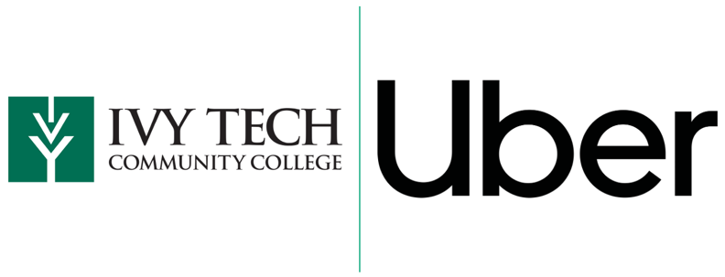
Uber + Ivy Tech Partnership
Tuesdays @ the Tech
Partnership Overview

- Ivy Tech and Uber are partnering with Tuesdays @ The Tech
- Participants are eligible for a $100 voucher per 6-week Campaign
- Available on Tuesdays from 9:00 am – 8:00 pm (Central & Eastern)
- Parameter set for 25-mile radius
- Participants are responsible for any costs over the $75 voucher
- Participants must be 18+ or older

How it Works

Students will receive an email via Tuesday @ The Tech School Spotlight | Tuesday @ The Tech website will be updated with unique QR Code | Vouchers will be valued up to $100 per participant (expires 08/08/2023)

Participating Campuses

Anderson  Bloomington  Columbus  Crown Point  East Chicago  Evansville  Fort Wayne | Gary  Hamilton County  Indianapolis & Lawrence  Kokomo  Lafayette  Lawrenceburg  Madison | Marion  Muncie  Richmond  Sellersburg  South Bend  Terre Haute  Valparaiso

